Title: Linux Command List Assessment

Name: Deepa
Registration Number: 20BCI0116
Assignment: 1

Instructions:-

The following assessment aims to test your understanding and practical knowledge of various Linux commands. Perform the tasks given below using the appropriate commands. Write down the command(s) used to complete each task. You can use any Linux distribution or command-line interface of your choice. Ensure that you provide the correct output or results for each task.

Note: It is recommended to perform this assessment on a Linux machine or virtual environment.

File and Directory Operations:
ls: List files and directories
cd: Change directory
pwd: Print working directory
mkdir: Make directory
touch: Create an empty file
cp: Copy files and directories
mv: Move or rename files and directories
rm: Remove files and directories
find: Search for files and directories

Output:

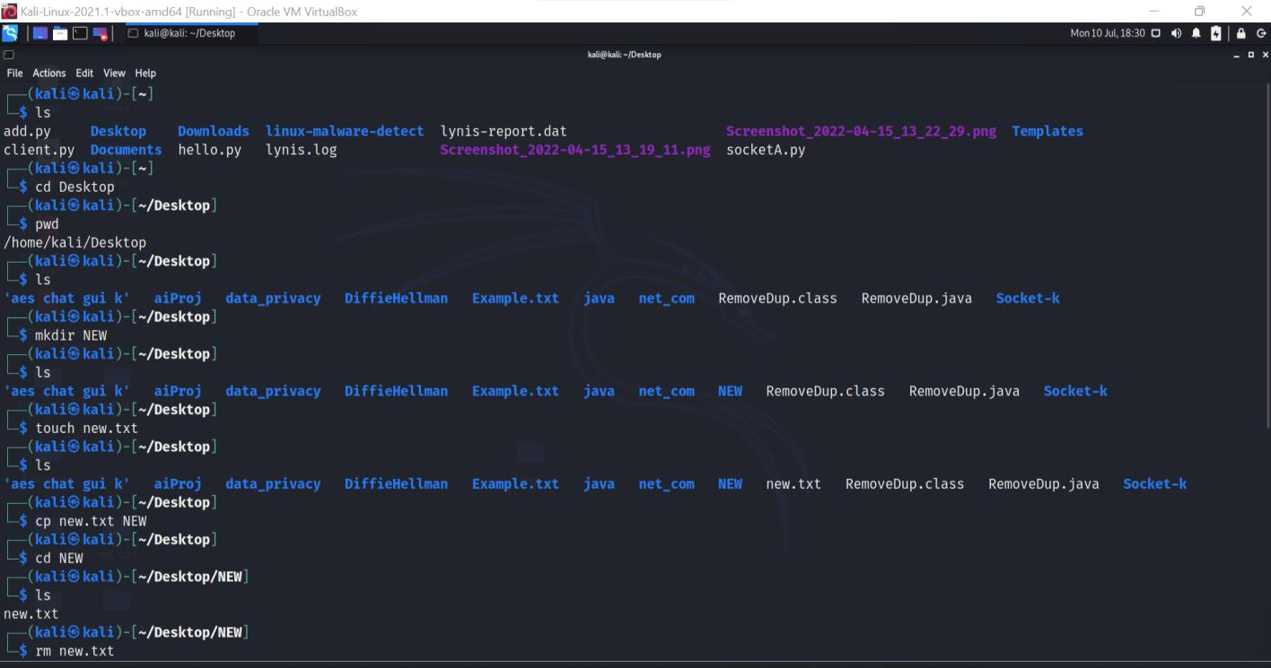

.
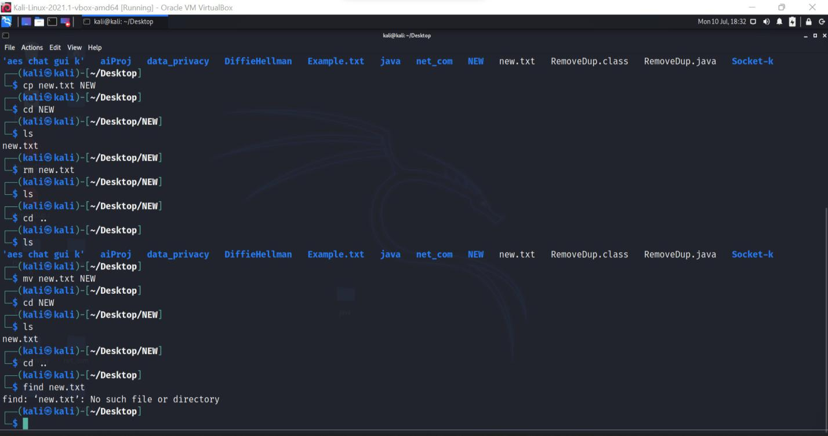

.

File Viewing and Editing:
cat: Concatenate and display file content

less: View file content with pagination
head: Display the beginning of a file

tail: Display the end of a file
nano: Text editor for creating and editing files
vi/vim: Powerful text editor for experienced users

Output:
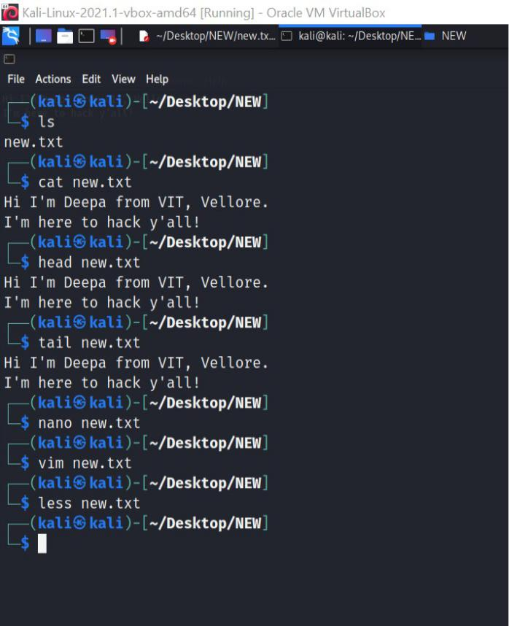

.
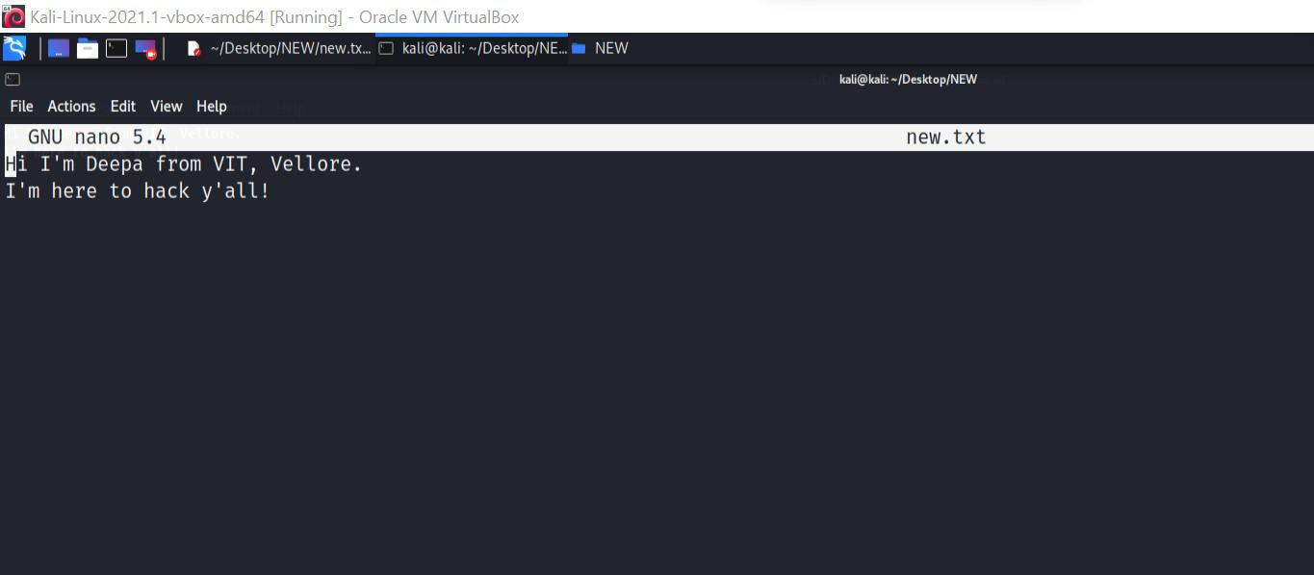

.

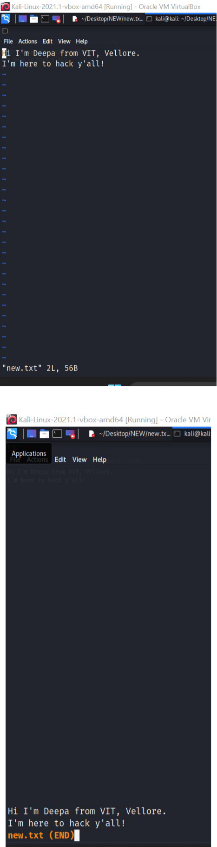

.

File Permissions:
chmod: Change file permissions
chown: Change file owner
chgrp: Change file group

Output:
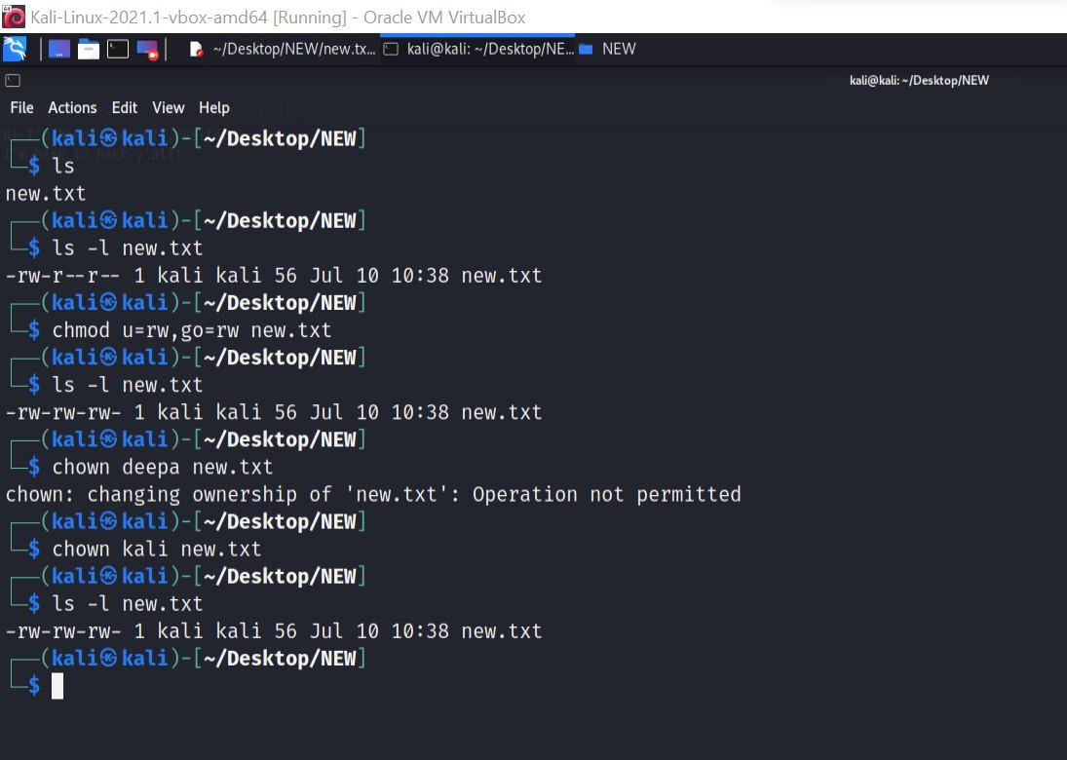

.

File Compression and Archiving:
tar: Archive files
gzip: Compress files
unzip: Extract files from a ZIP archive

Output:
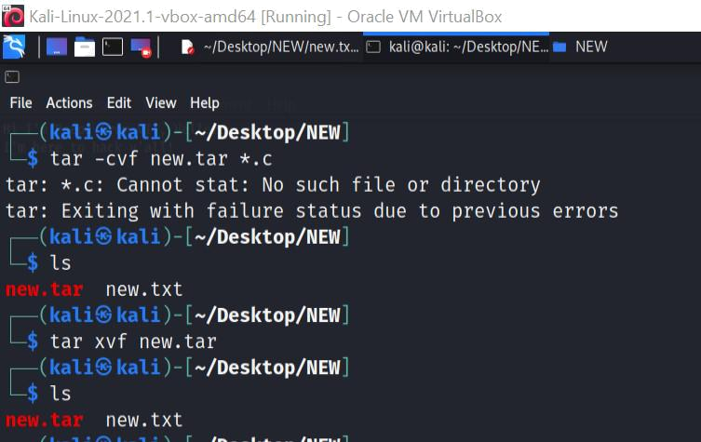

.
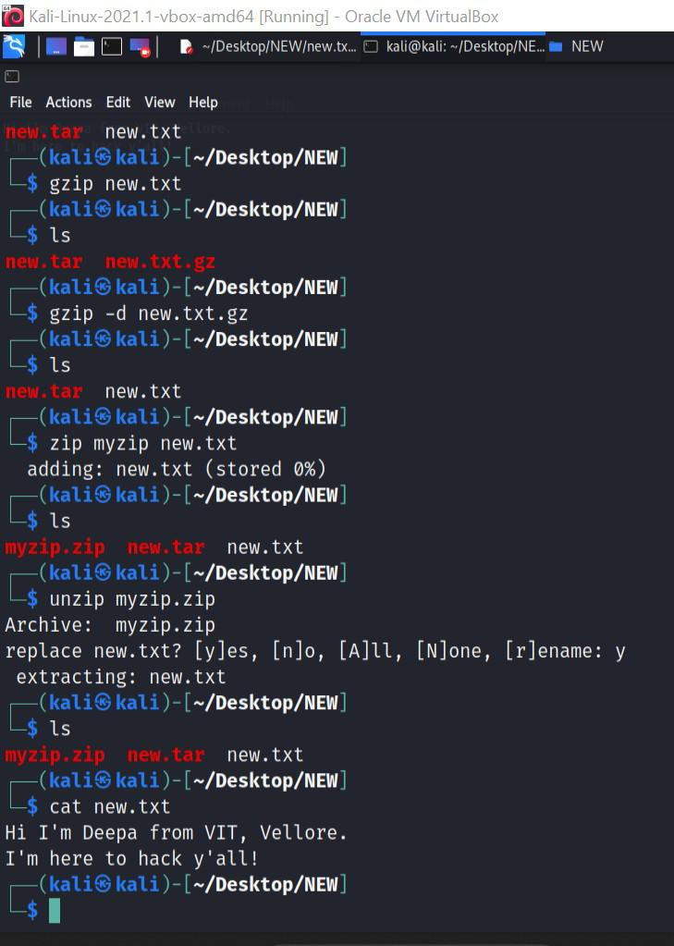

.

Process Management:
ps: List running processes
top: Display real-time system information and processes

kill: Terminate processes
bg: Run processes in the background
fg: Bring background processes to the foreground

Output:
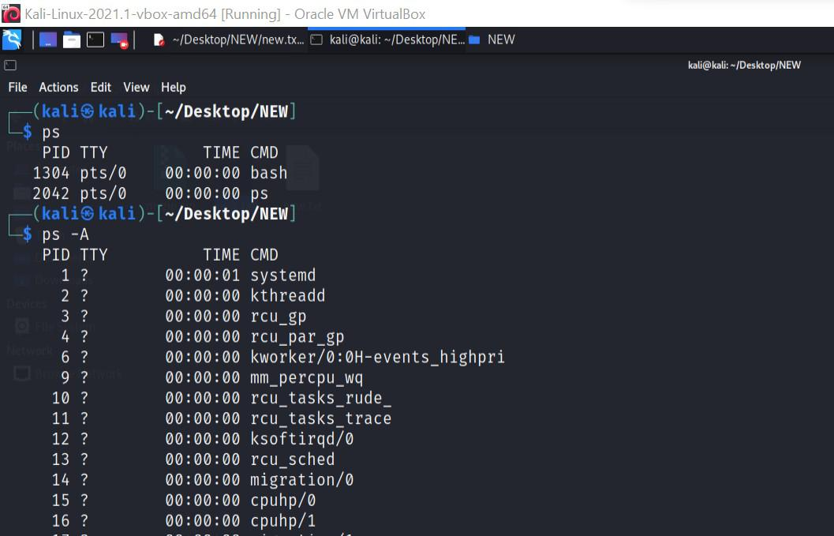

.
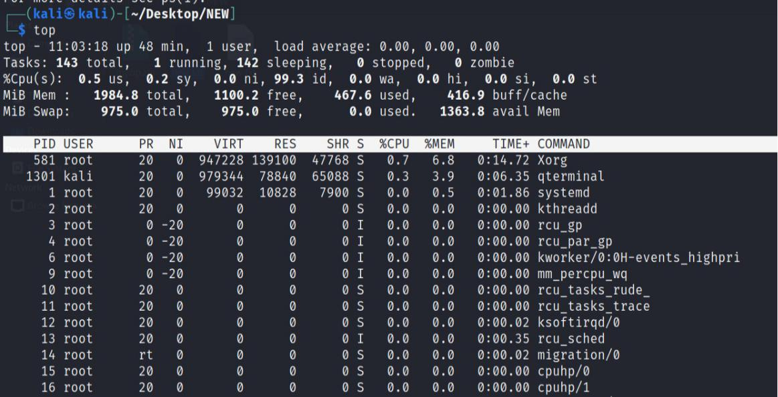

.

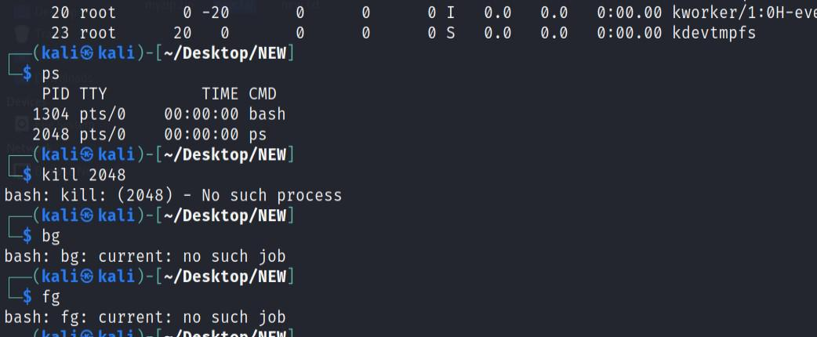

.

System Information:
uname: Print system information
df: Display disk space usage
free: Display memory usage
uptime: Show system uptime
who: Display logged-in users
- Display logged-in users and their activities Output:

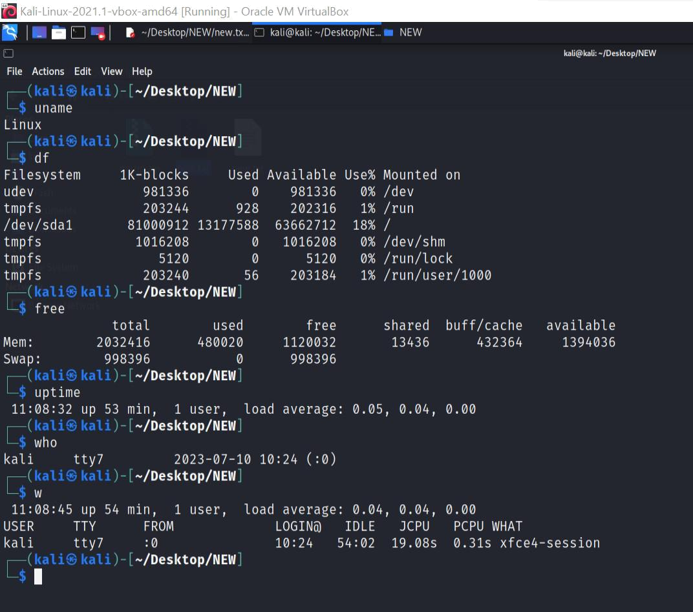

.

Networking:
ifconfig: Configure network interfaces
ping: Send ICMP echo requests to a network host

ssh: Securely connect to a remote system
scp: Securely copy files between systems
wget: Download files from the web

Output:

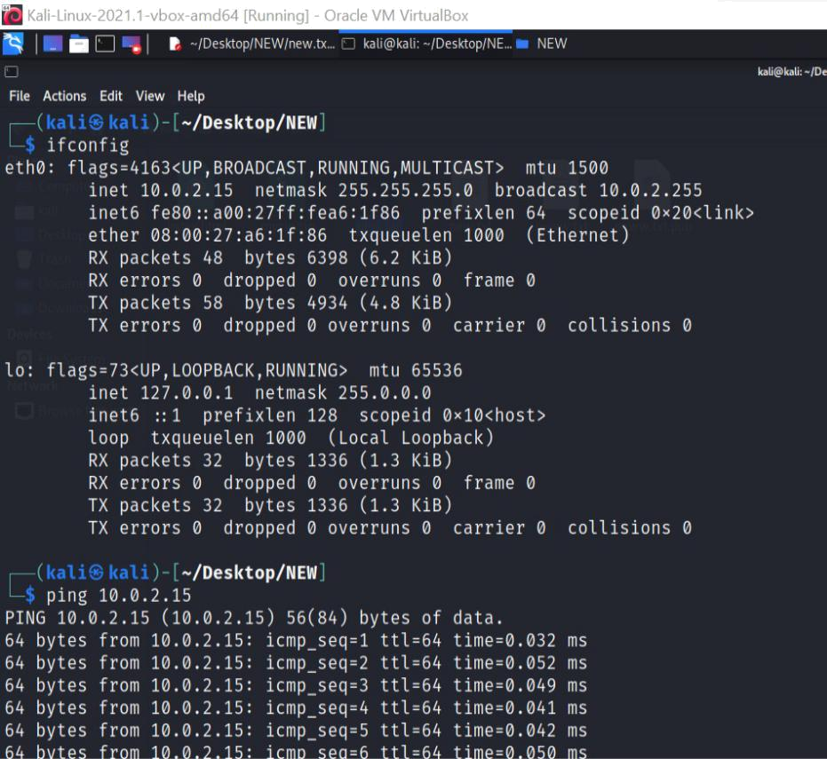

.
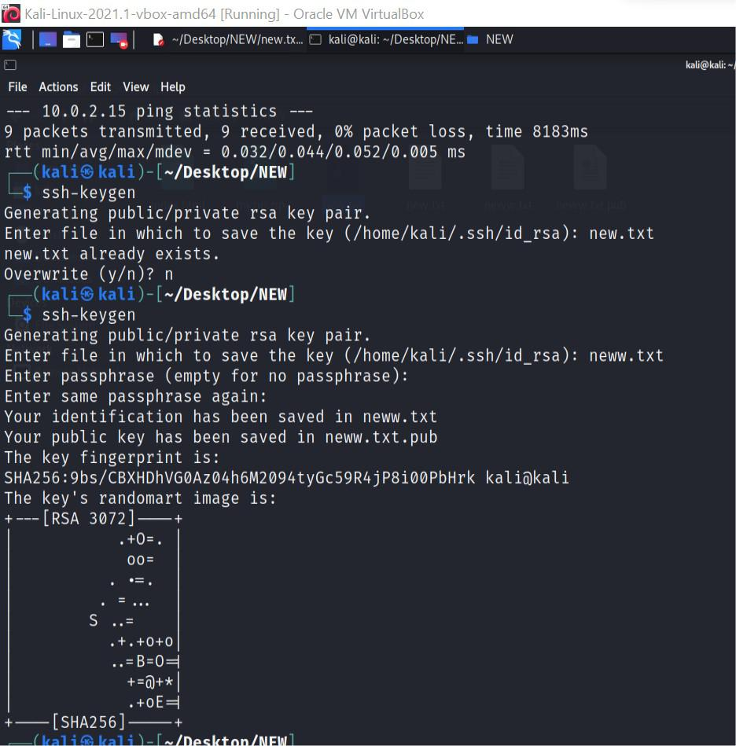

.

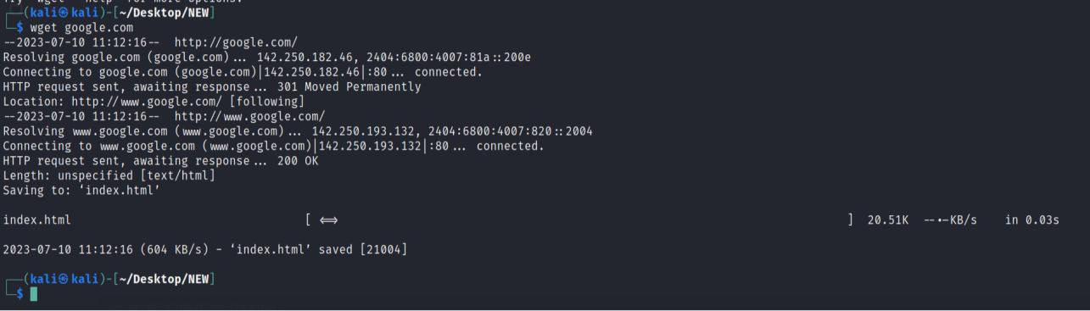

.

System Administration:
sudo: Execute commands with superuser privileges
apt-get: Package management for Debian-based distributions

yum: Package management for Red Hat-based distributions
systemctl: Manage system services
crontab: Schedule recurring tasks
useradd: Add a new user
passwd: Change user password

Output:
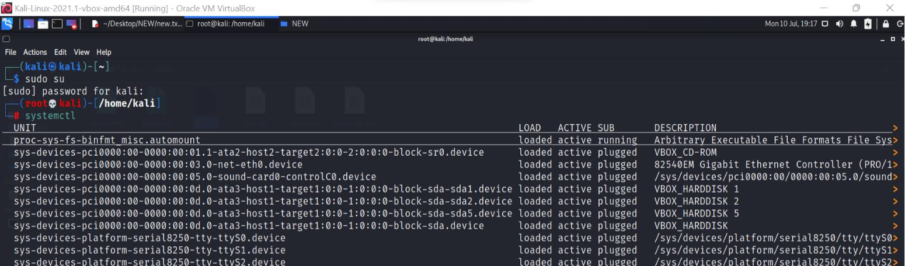

.
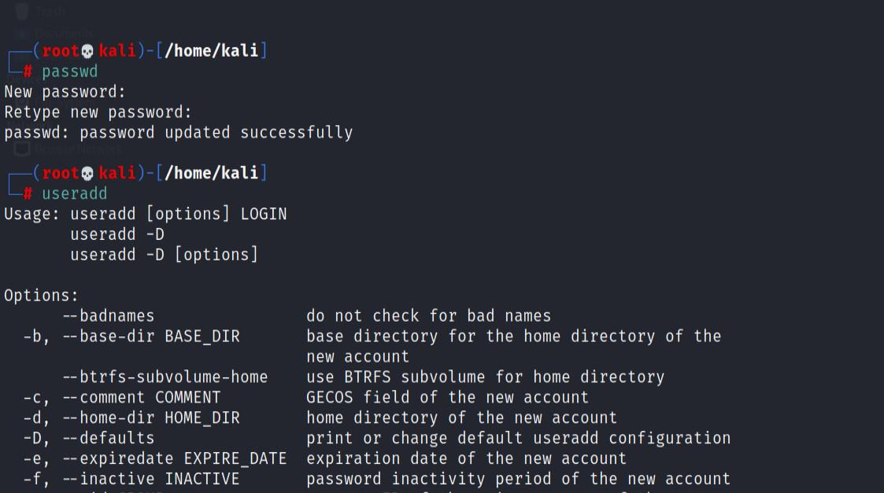

.

Thank you!!

